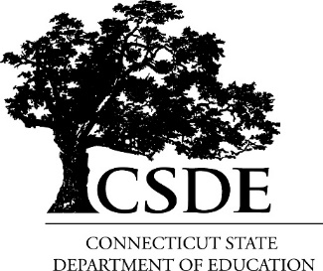
Career and Technical Education Unit
Update: Connecticut Perkins V Comprehensive Local Needs Assessment (CLNA) Timeline and Completion Steps
(For districts who submitted a CLNA Update in 2024 submission for 2025 is optional)
Due no later than June 30, 2025

- Watch CLNA Update Process Webinar if you need a refresher. The webinar can be found on the dedicated Perkins V: Today’s Skills, Tomorrow’s Careers Webpage.

- Follow the four steps as detailed in the CLNA Update Process Webinar and summarized below:
    - Step One CLNA Update: Organize Stakeholders
    - Step Two CLNA Update: Analyze Student Data
    - Step Three CLNA Update: Analyze Market Data
    - Step Four CLNA Update: Evaluate Current Programs

- Complete and submit template attached and found on the Perkins V: Today’s Skills, Tomorrow’s Careers Webpage.
  - The CLNA Update Template must be submitted to your Perkins Program Manager no later than June 28, 2025.

Connecticut Perkins V Comprehensive Local Needs Assessment (CLNA) Update
Revisiting, Reflecting, Reviewing, and Revising

Name of Local Eligible Recipient: _________________________________________________
Individual Completing Form: ____________________________________________________
Email: ______________________________________________________________________
Date(s) of CLNA Update mandatory meeting(s):____________________________________________________________________
Expanded group of mandatory stakeholders included: ________ yes __________ no

Instructions: Using bulleted formatting, please complete the following sections:

I. Alignment to local labor market needs (analyze local labor market data, cite sources)

II. Size, scope and quality of programs offered (goals, strategies, and actionable activities)

III. Progress toward implementing programs of study (goals, strategies, and actionable activities)

IV. Progress on federal accountability indicators (goals, strategies, and actionable activities)

V. Progress on improving access and equity (goals, strategies, and actionable activities)

VI. Progress on Recruitment, Retention, and Training of Faculty and Staff (goals, strategies, and actionable activities)

