
Updated on
January 5, 2021

OCC FACT SHEET: ELECTRIC SUPPLIER MARKET, SEPTEMBER 2019 THROUGH AUGUST 2020

The following is an update to the Office of Consumer Counsel’s (OCC’s) Electric Supplier Market Fact Sheet, originally created in 2014. The numbers provided herein are based on data submitted as compliance filings in the Public Utilities Regulatory Authority’s Docket Number 06-10-22.

- Retail suppliers serve 19.1% of Eversource Energy (Eversource) residential customers and 24.2% of United Illuminating (UI) residential customers, in August 2020.

- In the month of August 2020, nearly nine out of ten residential supplier customers paid more than the Standard Offer in Eversource territory, and seven out of ten residential supplier customers paid more than the Standard Offer in UI territory.

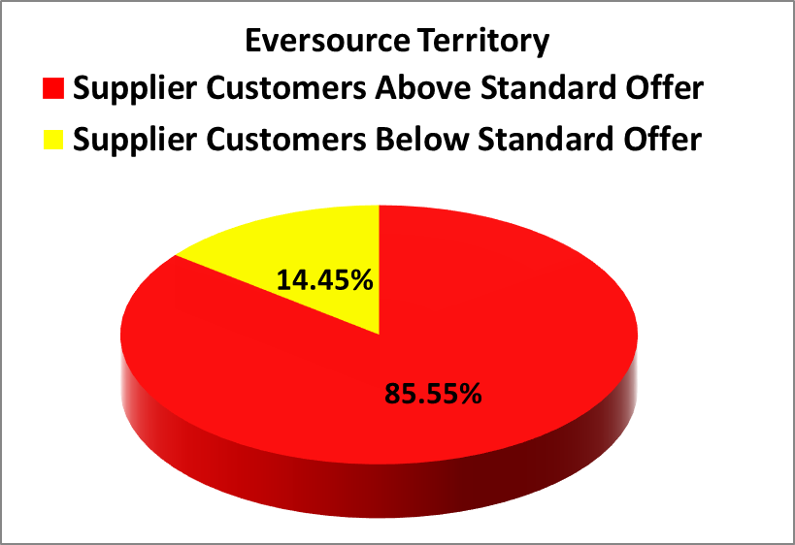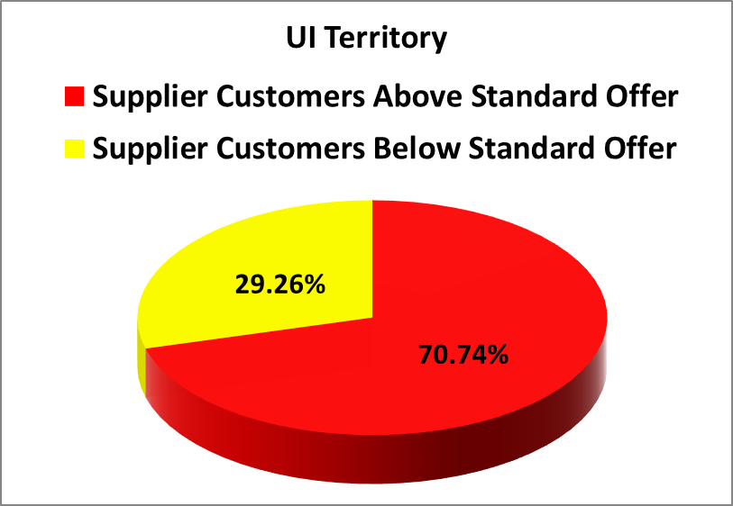
- In the month August 2020, residential Eversource customers who chose suppliers paid in aggregate $3,746,865 more than the Standard Offer for their electric generation, and residential UI customers who chose suppliers paid in aggregate $825,038 more than the Standard Offer.
- For the rolling year of September 2019 through August 2020, residential consumers who chose a retail supplier paid, in aggregate, $39,552,852 more than the Standard Offer.
- The Standard Offer for Eversource customers from From July 1, 2019 through December 31, 2019 was 8.123 cents/kWh The Standard Offer for Eversource customers from January 1, 2020 through June 30, 2020 was 9.414 cents/kWh. For July 1, 2020 through December 31, 2020 the Standard Offer is 7.375 cents/kWh
- The Standard Offer for UI customers from From July 1, 2019 through December 31, 2019 was 8.3532 cents/kWh The Standard Offer for UI customers from January 1, 2020 through June 30, 2020 was 10.5607 cents/kWh. For July 1, 2020 through December 31, 2020 the Standard Offer is 8.6672 cents/kWh.
- As of July 1, 2020 customers coded as hardship were returned to standard service. Suppliers are no longer able to serve hardship coded customers going forward in Connecticut as a result of PURA ruling in Docket No. 18-06-02.

Suppliers Charging at Least 20% of their Customers 50% or more than Standard Offer in August
Electric Suppliers | % of Eversource Customers paying over 11.0625 cents | % of UI Customers paying over 13.000 cents | Supplier Phone Number
Choice Energy | 99.77% | 42.47% | (888) 565-4490
Energy Plus Holdings, LLC | 92.85% | 86.29% | (888) 766-3509
North American Power and Gas LLC | 42.96% | 36.90% | (877) 572-0442
Ambit Energy LLC | 24.05% | 46.45% | (877) 282-6248
Liberty Power Holdings LLC | 23.19% | N/A | (866) 769-3799
NRG Retail Solutions | 95.79% | 86.72% | (855) 500-8703
Public Power LLC | 35.93% | N/A | (888) 354-4415
Spark Energy LP | 82.76% | 85.21% | (877) 547-7275
Sunwave Gas and Power CT Inc. | 46.09% | 35.64% | (855) 478-6928
Verde Energy USA Inc. | 73.31% | 60.58% | (800) 388-3862
Viridian Energy Inc. | 83.45% | 36.12% | (866) 663-2508
CT Gas and Electric Inc. | 32.37% | N/A | (855) 799-8200
Discount Power Inc. | 47.55% | N/A | (203) 929-3200
Mega Energy of New England LLC. | 37.33% | N/A | (855) 810-6342
Xoom Energy Connecticut LLC | 27.24% | N/A | (888)-997-8979
Major Energy Electric Services LLC | 28.06% | 51.24% | (888) 625-6760

Please feel free to contact the Office of Consumer Counsel at 860-827-2900 or occ.info@ct.gov if you have any questions about this information.

This Fact Sheet only examines available data regarding pricing by electric suppliers. While some suppliers may offer products or services to customers such as airline miles or a product with additional renewable energy content, there is no data available to quantify the value of such offers. OCC recommends that customers look carefully at the fine print for offers for additional products or services that come with higher prices, to ensure they are getting sufficient value to justify the higher price tag.
These calculations are based on an assumption of 750/month kWh usage.

